**Leader Overview**

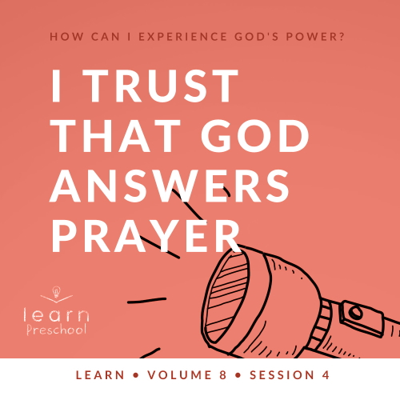

**Volume Overview**

**How can I experience God’s power?**

*When we think of power, we might think of physical strength or mental toughness. While God surely wants us to experience physical health and clarity of mind, He desires that we experience His supernatural power too.*

*In the Bible, it’s clear that our God—revealed through the Father, the Son and the Holy Spirit—is powerful. He spoke the world into existence and sustains the universe by the power of His Word (*[*Hebrews 1:3*](https://ref.ly/logosref/Bible.Heb1.3)*). God displayed His power in many ways in the Old Testament for His people. In the New Testament, Jesus’ life and works revealed His power over sickness, spiritual forces, and even the grave. After Jesus’ resurrection, God sent the Holy Spirit so we could have the power to do kingdom work today (*[*Acts 1:8*](https://ref.ly/logosref/Bible.Ac1.8)*). Clearly, God is powerful! But how do you and I experience His power? That’s the question we’ll explore in this volume.*

**Session Overview**

**I Trust That God Answers Prayer**

*In this* **Learn** *session, preschoolers will discover the truth that God not only hears our prayers, but He also acts in response to them. We’ll explore how incredible it is that the God who created the universe and knows the stars by name also knows each one of us by name and invites us to be a part of His miracles through prayer.*

**Bible Lesson**

God Answers Elisha’s Prayers

[2 Kings 6:14–23](https://ref.ly/logosref/Bible.2Ki6.14-23)

**Faith Fact**

I believe God can answer prayer.

**Faith Verse**

[John 14:12](https://ref.ly/logosref/Bible.Jn14.12) (NLT)

“I tell you the truth, anyone who believes in me will do the same works I have done.”

**Preparing for the Session**

**Leader Preparation Time: 20–25 Minutes**

|  |
| --- |
| ***You Will Need***  ***Preservice Activities***  *• Toys*  *• Small fan*  *• Piece of paper*  *• Frosted cookies*  ***Large Group***  *• Bible*  *• Worship songs (Song suggestions: “My God Is So Big” by Hosanna Kids; “What a Mighty God We Serve” by Christian Songs for Kids; “Love the Lord” by CJ and Friends)*  *• For groups not using a phone or tablet only, add:*  *• Projector or TV*  *• Laptop*  *•* ***Faith Fact Sound video*** *(bell ringing)*  *•* ***Faith Fact Slide***  *•* ***Faith Verse Slide***  *•* ***Bible Lesson Video A***  *•* ***Bible Lesson Video B***  ***Small Group***  *•* ***Small Group Group Connection Page 1****, one per group*  *•* ***Small Group Group Connection Page 2****, one per ten kids*  *• Scissors*  *• Tape*  *•* ***Small Group Activity Page****, one per kid*  *• Crayons or markers*  *•* ***Small Group Feet-to-Floor Game Time Page****, one per group*  *• Scissors*  *• Tape*  *• Ball*  *• Basket or trash can*   * *Playdough* * *Pencils* * *Cotton swabs, five per kid*   *To access session content and videos from a computer, visit:* [*BibleEngagementProject.com/downloads*](https://bibleengagementproject.com/downloads) |
| ***Getting Ready***  ***Preservice Activities***  *• Set out toys and snacks.*  ***Large Group***  *• Download videos and slides if needed.*  *• Select worship song(s) and have them ready to play.*  ***Small Group***  *• Print and tape to the wall the* ***Small Group Group Connection Page 1****, one per group.*  *• Print and cut apart* ***Small Group Group Connection Page 2****, one per ten kids.*  *• Print copies of the* ***Small Group Activity Page****, one per kid.*  *• Print the* ***Small Group Feet-to-Floor Game Time Page****, one per group.*  *• Tape signs at the four stations of the relay.*  ***First time leading* Learn *for Preschool? Check out the*** [**Facilitator Guide**](https://0b769b0ed3569ef9d18b-f88d8272f61086866d50d048b43ef630.ssl.cf2.rackcdn.com/sites/biblengagementproject/Listen_Facilitator_Guide.pdf)**.** |

**Preservice Activities**

*See what’s needed at the beginning of the session.*

**Bible Story Warm-Up**

Welcome, everyone! *(Point to eyes.)* What do we use these for? *(Allow responses.)* Yes, we use our eyes to see. Can we see the wind? *(Allow responses.)*

• *Turn on the fan. Put the paper in front of the fan to move in the breeze.*

We can see that the wind moves things outside just like we just saw the paper move. We can feel the wind, but we can’t see it.

• *Give each kid a turn putting their hand in front of the fan to feel the breeze.*

What about when it’s nighttime and the light in your room is off? Your room isn’t as bright as it is during the day, is it? *(Group response)* So you can’t see everything as well as when the light is on. Think of something in your bedroom that may be very small and that you can’t see when the light is off. Raise your hand when you think of something.

• *Pause to give kids time to think.*

Does that thing disappear at night when you can’t see it? *(Group response)* Is it still there in the morning? *(Group response)* Yes, your stuff is there because that’s how God made the world. Let’s try one more thing. I’m going to crumple up this paper.

• *Hand it to a kid and instruct them to put it behind their back.*

Is the paper still there? *(Group response)* We can’t see it. Are you sure? *(Group response)* Can you show us the paper again?

• *Wait for the kid to show the paper.*

You’re right! The paper is still there. We can’t see everything, so sometimes we can’t see when God is doing things to help us. But just because we can’t see something doesn’t mean it’s not there or it’s not real.

• *Ask these questions.*

Can our eyes see everything?

What are some things our eyes can’t see?

Can we always see it when God is helping us?

God helps us when we pray even if we don’t see it right away. Later, we’ll see that God answered Elisha’s prayer in the Bible story. It began with a bad king who sent his army after Elisha. Elisha prayed for different things in this story, and God answered his prayers in amazing ways. I’m excited for you to hear the rest of the story with Lizzy.

**Snack**

**Frosted Cookies**

I’m going to give you clues about how our Bible story ends. Let’s see if you can guess what happened. It ended with something you might send out invitations for. There’s often a fancy dessert or really good food. You might put up decorations. Maybe there are balloons. Does anyone have a guess what it is? *(Allow responses.)* You’re right. It’s a party.

Since there’s a party at the end of our Bible story, I thought we should have something special for our snack.

• *Give kids the snack.*

If you had a party, who would you invite? *(Allow responses.)* In our Bible story, a bad king sent his army to hurt Elisha. That mean king was Elisha’s enemy. An enemy is the opposite of a friend. At the end of our Bible story when Elisha asked for a party, he invited the enemy army to eat the good food. God answered Elisha’s prayer in some amazing ways to make all of that happen.

**Free Play**

*Any extra time can be spent playing with toys.*

**Transition**

*A few minutes before service begins have kids make their way to the large group area and sit in their designated areas.*

**Large Group**

**25 Minutes**

*See what’s needed at the beginning of the session.*

**Introduction**

I’m excited to explore this exciting Bible story with you today. If it’s in the Bible, we know it’s true. *(Hold up Bible.)* Our Bible story today teaches us that we can trust God to answer prayer. A bad king sent his army to go get Elisha. Now, Elisha’s servant was very scared when he saw the army coming. Show me your scared face. *(Group response)* Elisha prayed, and God opened the servant’s eyes. Everyone, put your hands over your eyes like you can’t see. *(Group response)* Now, move your hands and open your eyes really big. God answered Elisha’s prayer and opened the servant’s eyes to see something amazing. This Bible story shows us that God answers prayer.

**Faith Fact**

Oh, wait! I think that’s our Faith Fact today. **I believe God can answer prayer.**

• *Show the* ***Faith Fact Slide.***



Let’s say it together. **I believe God can answer prayer.** God hears our prayers the moment we say them, so let’s make our hands into a megaphone around our mouth as we say the Faith Fact. *(Demonstrate placing your hands around your mouth for the kids.)* **I believe God can answer prayer.** God knows our prayers the moment we think them, so let’s put our hands on our head while we say it one more time. **I believe God can answer prayer.**

**Bible Time**

It’s time to check in with Lizzy and see what she’s doing today. Are you ready to watch this video? *(Group response)* Then let’s watch and listen.

• *Play* ***Bible Lesson Video A****.*

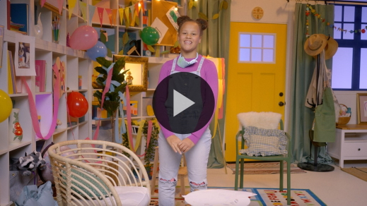

Sounds like Lizzy is planning a fun party! A birthday party for a dog? That sounds like a lot of fun! Great job helping her practice our Faith Verse! You know it so well.

**Worship**

One way we show God how thankful we are for the Bible is through praise and worship. Let’s take some time to thank God for how much He loves us.

**Praise**

Are you glad we can trust God? Touch your toes down low. *(Group response)*

Are you glad God loves us? Wave your hands up high. *(Group response)*

Who wants to tell God thank You for answering prayer? Clap your hands. *(Group response)*

**Sing**

One way we can worship God is by singing. Let’s use our voices to tell God how great He is.

• *Lead the kids in singing one or two songs. See song suggestions at the beginning of the session.*

**Prayer**

Before we pray, let’s talk about prayer. What do you think prayer is? *(Allow responses.)* Those are great answers. Prayer is talking to God just like we talk to a friend, a parent, or grandparent. It’s also listening because God may talk to us. He will answer our prayers. Isn’t it cool that the God who created the world wants to talk to you and me? *(Group response)* Let’s bow our heads to pray.

|  |
| --- |
| God, thank You for answering our prayers. You are so big and strong, but You don’t look down on us when we’re small or scared. You invite us to talk to You, and You love us so much. We love You. Amen. |

**Bible Time cont’d**

Let’s check back in with Lizzy to see if she’s ready for the party.

• *Play* ***Bible Lesson Video B.***

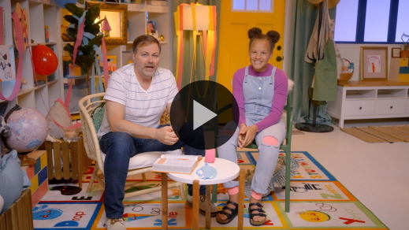

Wow, wasn’t that Bible story amazing? *(Group response)* I loved hearing how God answered Elisha’s prayers. Now, I want you to show me how well you were listening to the Bible story. Who was surrounded by an enemy army? *(Allow responses.)* That’s right! Elisha and his servant were surrounded by the enemy army.

Who was scared? *(Allow responses.)* Yes, Elisha’s servant was scared, so Elisha prayed for him. When Elisha prayed for his servant’s eyes to be opened, the servant saw that an army from God was there to help them. Later, Elisha prayed for the enemy army to not be able to see, and what did God do? *(Allow responses.)* God blinded their eyes. Elisha led them to his king. But instead of hurting the enemy army, the king threw a party for them. God answered Elisha’s prayers in amazing ways.

It always makes me feel safe to know that God answers prayer. Sometimes I’ve felt like Elisha’s servant who couldn’t see God’s answer at first. After I’ve prayed for God to open my eyes, He shows me He is with me.

**Response Time**

• *Play a worship song quietly.*

Let’s take some time to respond to what we’ve discovered today. Put your hands together as we pray. When you pray, you can just talk to God about whatever you’re thinking about. Let’s do that now. Pray out loud to God or think about what you want to say to Him.

• *Pause for kids to pray.*

Now, if you need God to do something special in your life, lift your hand. *(Group response)* By lifting your hand, you’re showing God that you know He can answer prayer and that you’re asking Him to do it. Let’s pray together for these things.

|  |
| --- |
| God, we thank You that You hear our prayer. You see everyone here with a lifted hand and You know exactly what they need. I pray You answer their prayers in a mighty way. Open their eyes to see that You are with them and helping them. Amen. |

**Faith Verse**

It’s so good to pray together with you. I also love learning Bible verses with you. Let’s practice our Faith Verse all together one more time.

[John 14:12](https://ref.ly/logosref/Bible.Jn14.12) (NLT)

“I tell you the truth, anyone who believes in me will do the same works I have done.”

• *Show the* ***Faith Verse Slide****.*

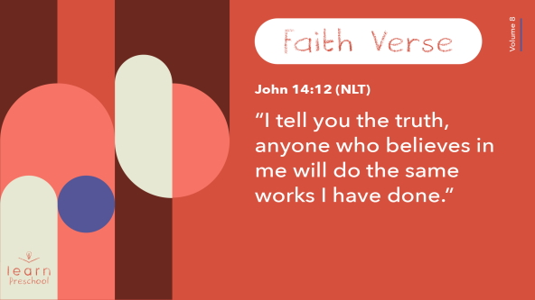

You’ve done a great job of memorizing that Faith Verse!

**Closing**

Raise your hand if you can tell me one thing you’ve learned today. *(Allow responses.)* It’s been so great exploring that God answers prayer today.

• *Play the* ***Faith Fact Sound*** *video (bell ringing).*

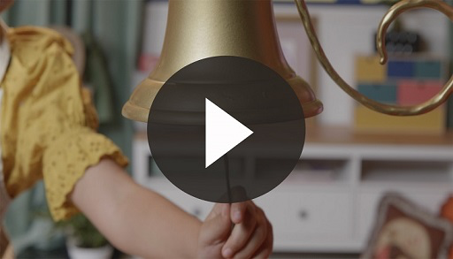

That sounds means it’s time to say our Faith Fact one more time. **I believe God can answer prayer.**

• *Show the* ***Faith Fact Slide.***



Let’s have faith like Elisha and say it loudly so that everyone in the building can hear it. **I believe God can answer prayer.** Now, let’s whisper it because God hears our prayers even when we whisper them. **I believe God can answer prayer.**

**Dismissal to Small Groups**

Great job! Now you get to go with your friends in small group to do some really fun activities.

• *Dismiss the kids by groups*.

|  |
| --- |
| ***Leader Tip:*** *This can be done by assigning color teams or by age groups. Note that some young preschoolers may not know their age. Using a colored sticker, jersey, or wristband will help separate the kids and help identify their small groups.* |

**Small Group**

**25 Minutes**

*See supplies and prep instructions at beginning of session or in each activity below.*

|  |
| --- |
| ***Leader Tip:*** *Small groups can alternate to each circle, or all groups can do each activity at the same time. If you choose to alternate, you will need at least one leader per circle.* |

**Circle 1**

**Group Connection**

**Pin the Glasses on Elisha’s Servant**

|  |
| --- |
| ***You Will Need***  *•* ***Small Group Group Connection Page 1****, one per group*  *•* ***Small Grou, Group Connection Page 2****, one per ten kids*  *• Scissors*  *• Tape*  ***Getting Ready***  *• Print and tape to the wall the* ***Small Group Group Connection Page 1****, one per group.*  *• Print and cut apart* ***Small Group Group Connection Page 2****, one per ten kids.* |

In our Bible story, Elisha’s servant was scared of the enemy army. We all get scared sometimes. Elisha wasn’t scared because he knew God was with them. Today, we’ll help Elisha’s servant see God’s army.

Here is Elisha’s servant, and he’s very scared. We need to help him see that God is with them. Let’s pretend these are special “see God’s help” glasses. *(Hold up glasses picture.)* We’ll take turns taping the glasses on to Elisha’s servant. Where are glasses normally worn? *(Group response)* Right! You can put the glasses over his eyes. As you put the glasses on him, the rest of us will say the Faith Fact to cheer you on. **I believe God can answer prayer.**

• *Hand each kid a pair of glasses and attach tape to the glasses when it’s their turn.*

• *Lead the kids in saying the Faith Fact each time.*

Look at how many glasses Elisha’s servant has! He can surely see that God answers prayer now. Great job, everyone! Now, I have something I want you to put on.

• *Pretend to pull a pair of glasses out of your pocket.*

I have a pair of special glasses for each of you that will help you see God’s help. I want you to wear them every day.

• *As you talk, pretend to place glasses in each kid’s hands.*

You never have to take these special glasses off. You can even sleep in them. I want each of you to remember to watch for how God is answering your prayers and how He is taking care of you every day. Let’s put them on.

• *Demonstrate putting on glasses.*

How do they fit? *(Group response)* You all look so good in your glasses. We know that we’re just pretending with the glasses, but it’s true that we can always be looking for God’s help in our life. If you want to pretend that we’ve got the coolest glasses around, wear them with me this week. If you don’t want to pretend, that’s okay, too. I still want you to be watching for how God is helping you.

**Circle 2**

**Activity Page Time**

**Elisha Leads the Army**

|  |
| --- |
| ***You Will Need***  *•* ***Small Group Activity Page****, one per kid*  *• Crayons or markers*  ***Getting Ready***  *• Print copies of the* ***Small Group Activity Page****, one per kid.* |

When Elisha prayed and asked God to blind the enemy army, what did God do? *(Group response)* God answered Elisha’s prayer!

• *Hand out a copy of the* ***Small Group Activity Page*** *and crayons to each kid.*

What do you think this image is at the top? *(Allow responses.)* The enemy army was scary. What do you notice at the bottom? *(Allow responses.)* Where did Elisha lead the enemy army? *(Allow responses.)* Trace the lines to find out which one leads the army to Elisha’s king.

• *During the activity, interrupt and practice the Faith Fact.* **I believe God can answer prayer.**

• *Play the* ***Faith Fact Sound*** *video. Review the Faith Fact even if you can’t play the sound.*



**Circle 3**

**Feet-to-Floor Game Time**

**Prayer Delivery Relay**

|  |
| --- |
| ***You Will Need***  *•* ***Small Group Feet-to-Floor Game Time Page****, one per group*  *• Scissors*  *• Tape*  *• Ball*  *• Basket or trash can*  ***Getting Ready***  *• Print the* ***Small Group Feet-to-Floor Game Time Page****, one per group.*  *• Tape signs at the four stations of the relay.* |

Today, we’ve talked about how God answers prayer. How does God know what we pray? *(Allow responses.)* God hears every word we say. He even knows what we think. He knows what’s in our heart. That means we never have to feel like we need to hide anything from God because He loves us so much.

For this game, we’ll pretend that we’re delivering our prayers to God. We’ll pretend these praying hands are our prayers. You’ll have to work together and use some strong muscles and fast feet for this game. Everyone, show me your arm muscles. *(Demonstrate flexing arms.)* Wow, you all have such strong muscles!

• *Demonstrate path and actions of relay as you explain.*

• *Select kids to be at each station as you explain that station.*

The first person will start here at station 1 with the prayer and run to the second station. That person will hand the prayer to the next person. The second person will walk on tiptoes to station 3. *(Demonstrate walking on tiptoes.)* You’ll hand the prayer to the next person. The third person will hop to station 4. *(Demonstrate hopping.)* The last person at station 4 will pick up the ball and throw it into this basket. If you miss, pick the ball up and keep throwing until you get it in. Finally, shout out our Faith Fact. **I believe God can answer prayer.** Then, the prayer is delivered. What do you think, team? Can we deliver these prayers? *(Group response)* Ready, set, go!

• *Cheer kids on and do the actions with them if kids are confused.*

Wow! Your fast feet and strong muscles delivered those prayers so quickly. You know what? I’m so thankful we don’t have to do this much work for God to hear our prayers. God’s plan to hear our prayers as we think them and say them is a lot better.

• *Repeat game as time allows with kids switching stations.*

**Circle 4**

**Hands-On Learning**

**Retell the Story with Play Dough**

|  |
| --- |
| ***You Will Need***  *• Play dough*  *• Pencils*  *• Cotton swabs, five per kid*  *No prep needed for this activity.* |

Let’s retell our Bible story with something that’s squishy and shapeable. *(Reveal play dough.)* Who loves this stuff? *(Group response)* First, I’m going to make Elisha. I think he needs a funny nose.

• *Make a round ball to be Elisha’s head. Use the pencil to poke eyes and a mouth.*

• *Add a small piece of play dough for his nose.*

Who came for Elisha? *(Allow responses.)* A big army that looked scary. I need your help to make the army. Let’s roll some clay into balls to be the army. To make a ball you take a piece of play dough and roll it like this in your two hands. Then, give the army mean looking eyes.

• *Hand out play dough to kids and help them make the army.*

Great job! Now, move the army close to Elisha. *(Use a gruff, deep voice.) “*We’re here to take you to our king, Elisha. You’d better be scared.” What do you think Elisha was thinking? *(Allow responses.)*

• *Hold up the Elisha head.*

*(Use a strong voice.) “*I’m not scared of you. I know God is with me.” Now, I’ll make Elisha’s servant. Oh! He’s so scared.

• *Make another round ball to be the servant. Draw a scared face with the pencil. Then, hold up the figure like he’s shaking.*

I think he might have said something like, “Elisha, what should we do?” Who remembers what Elisha did when his servant was scared? *(Group response)* Elisha prayed that God would open his servant’s eyes. Did God answer Elisha’s prayer? *(Group response)* That fits perfectly with our Faith Fact. Let’s say it together. **I believe God can answer prayer.**

What did Elisha’s servant see? *(Allow responses.)* God had sent His own army to protect Elisha and his servant. Let’s take these tall cotton swabs and stick them in a base of play dough to be God’s army. God’s army will be taller and bigger than the enemy army.

• *Demonstrate sticking cotton swab sticks into small pieces of play dough before handing out cotton swabs to the kids.*

Then, Elisha prayed again. Do you remember what he prayed? *(Allow responses.)* God answered his prayer, and the enemy army suddenly couldn’t see. Elisha walked up to them.

• *Demonstrate clay Elisha going up to clay army.*

Elisha led them to his king. Line up the army behind Elisha.

• *Give kids a moment to line up their army.*

What did Elisha’s king do? *(Allow responses.)* Yes, he threw a big party for them. I’m sure they were very surprised that Elisha and the king were so nice to them.

• *Optional: Have them make food for the party if they still have time.*

That was so much fun! I love seeing your play dough creations.

**Dismissal**

• *Play the* ***Faith Fact Sound*** *video (bell ringing).*



• *Show the* ***Faith Fact Slide.***



Before we go, let’s all say the Faith Fact one more time. **I believe God can answer prayer.** I had such a wonderful time learning about Elisha with you. See you next time!

• *Send home the* ***Small Group Activity Page*** *with each kid.*

• *Remind parents that there are* ***Family Devotions*** *available on the app to do with their kid.*

• *Tell everyone the date and time for the next session.*

.